**CYCLE – 1**

1. Print your name to the screen with every letter being a different heading size

<! DOCTYPE html>

<html>

<head>

<body>

<h1>S</h1>

<h2>E</h2>

<h3>B</h3>

<h4>Y</h4>

</body>

</head>

</html>

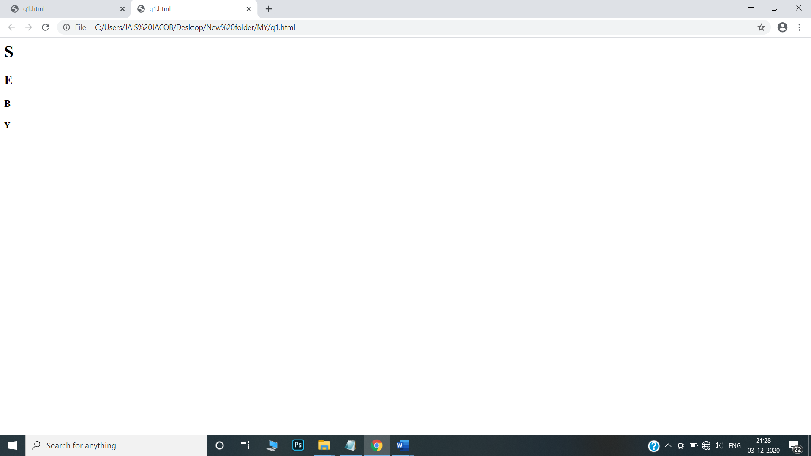

2.Display the following text:

H2O

12th April 2016

HTML stands for ~~High Text Markup Language~~

He said <**I am fine**>

<html>

<head>

<title>name</title>

</head>

<body>

<p> H<sub>2</sub>O<br>

12<sup>th</sup>April 2016 <br>

HTML stands for <del> High text Markup Language </del> <br>

He said <b> < I am fine> </b></p>

</body>

</html>

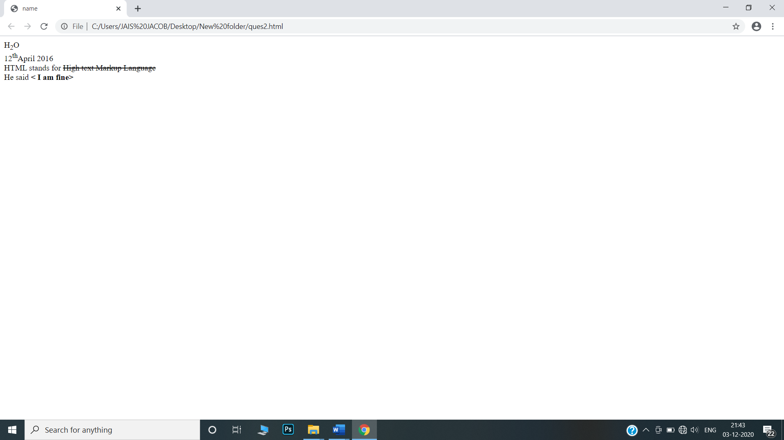

1. Print a paragraph with 4 - 5 sentences. Each sentence should be a different font.

<html>

<head>

</head>

<bod

<p><font size="6" face="Times New Roman">Routing is a process taking one packet from another.</font>

<font size="5" face="Courier New">It uses a network through internet.</font>

<font size="4" face="Wildwest">it is done with the help of ip address.</font>

<font size="3" face="Comic sans MS">diifrent types of routing techniques are available.</font>

<font size="2" face="Verdana">they are static routing,default routing.</font>

<font size="1" face="Arial">routing table is also available.</font></p>

</body>

</html>

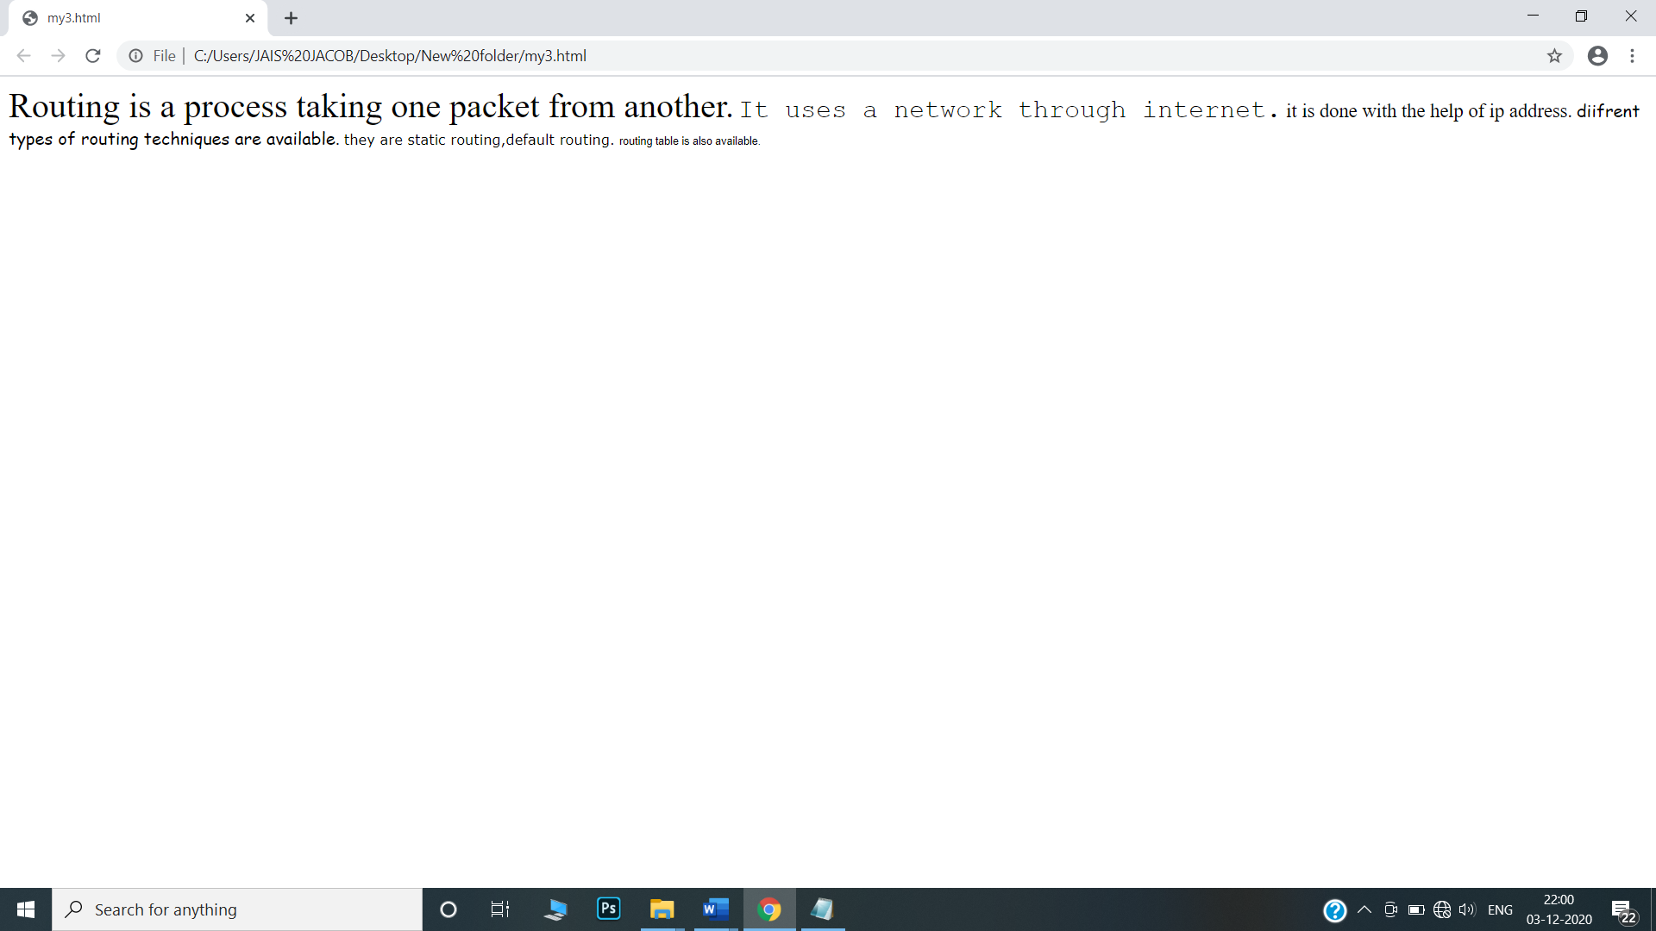

4.Print a paragraph that is a description of a book, include the title of the book as well as its author. Names and titles should be underlined, adjectives should be italicized and bolded

<html>

<head>

<title>Description of a Book</title>

</head>

<body>

<h1><u>MACBETH</u></h1>

<p>It is a novel by<u>Shakespeare.</u>,<b><i> A famous novelist</i></b>. The tragedy of Macbeth,is a tragedy by <u>Shakespeare</u> .</p>

<p><u>Shakespeare</u> is a well known <b><i> artisr,novelist </i></b>and this one was performed in the folio of 1623 possibly from a prompt book</p>

</body>

</html>

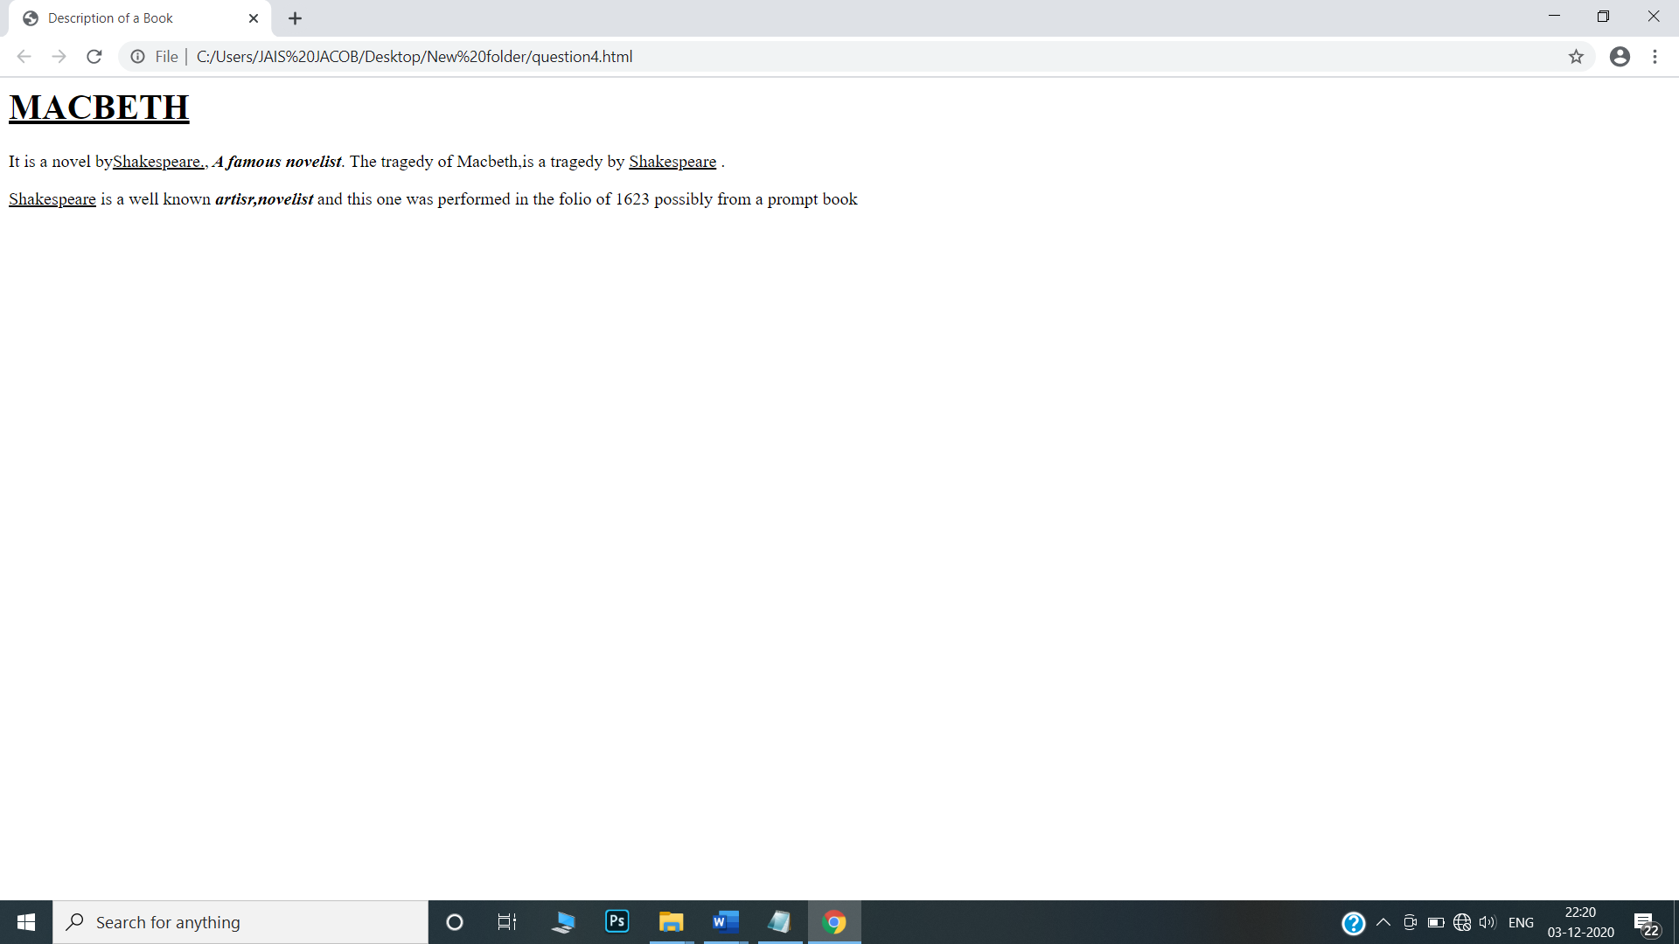

5.Print two lists with any information you want. One list should be an ordered list, the other list should be an unordered list.

<html>

<head>

</head>

<body>

<h1><u>LIST OF CARS</u></h1>

<ol>

<li>BMW</li>

<li>MARUTI</li>

<li>AUDI</li>

<li>HYUNDAI</li></ol>

<h1><u>LIST OF BIKES</u></h1>

<ul>

<li>BAJAJ</li>

<li>HERO</li>

<li>HONDA</li>

</ul>

</html>

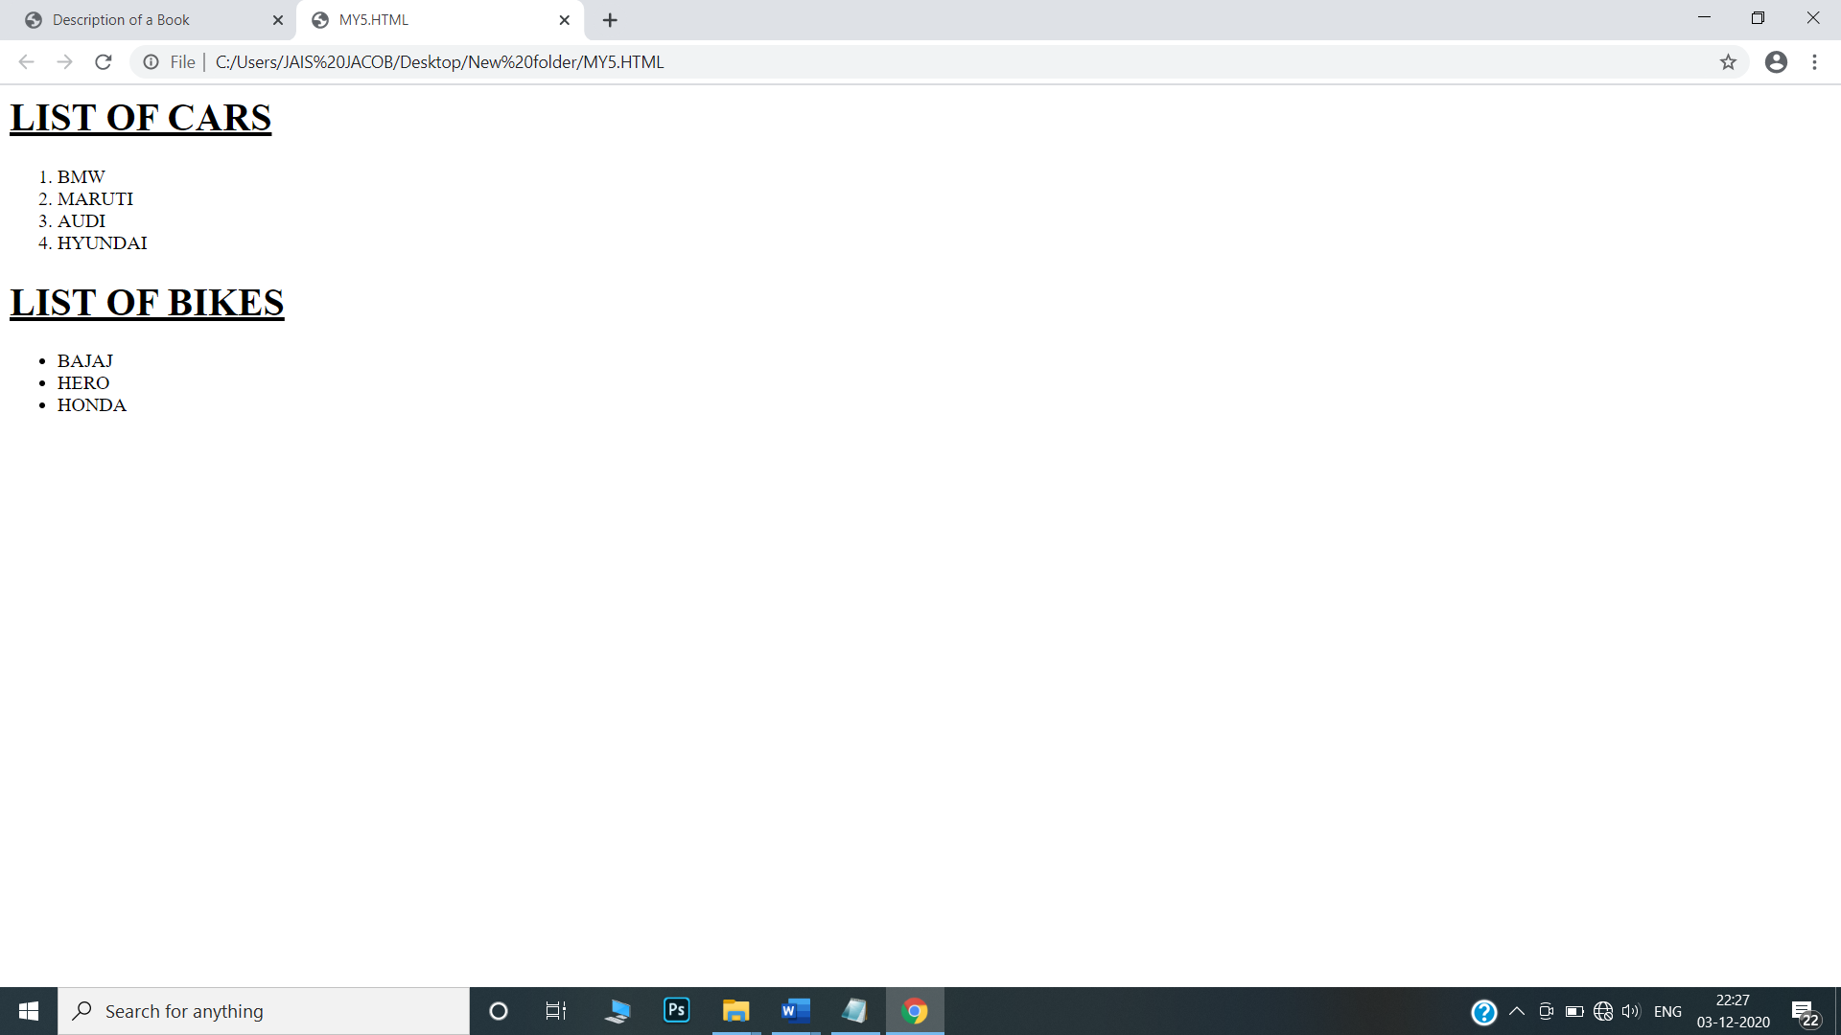

6. Prints 10 names with a line break between each name. The list should be alphabetized, and to do this place a subscripted number next to each name based on where it will go in the alphabetized list. (Example: Alan1). Print first, the unalphabetized list with a subscript number next to each name, then the alphabetized list. Both lists should have an <h1> level heading

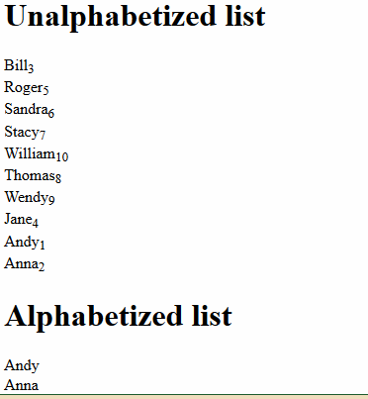

<html>

<head>

</head>

<body>

<h1>Unalphabetized list</h1>

Bill<sub>3</sub>

<br>

Roger<sub>5</sub>

<br>

Sandra<sub>6</sub>

<br>

Stacy<sub>7</sub>

<br>

William<sub>10</sub>

<br>

Thomas<sub>8</sub>

<br>

Wendy<sub>9</sub>

<br>

Jane<sub>4</sub>

<br>

Andy<sub>1</sub>

<br>

Anna<sub>2</sub>

<br>

<h1>Alphabetized list</h1>

<ol>

<li>Andy</li>

<li>Anna</li>

<li>Bill</li>

<li>Jane</li>

<li>Roger</li>

<li>Sandra</li>

<li>Stacy</li>

<li>Thomas</li>

<li>Wendy</li>

<li>William</li>

</ol>

</body>

</html>

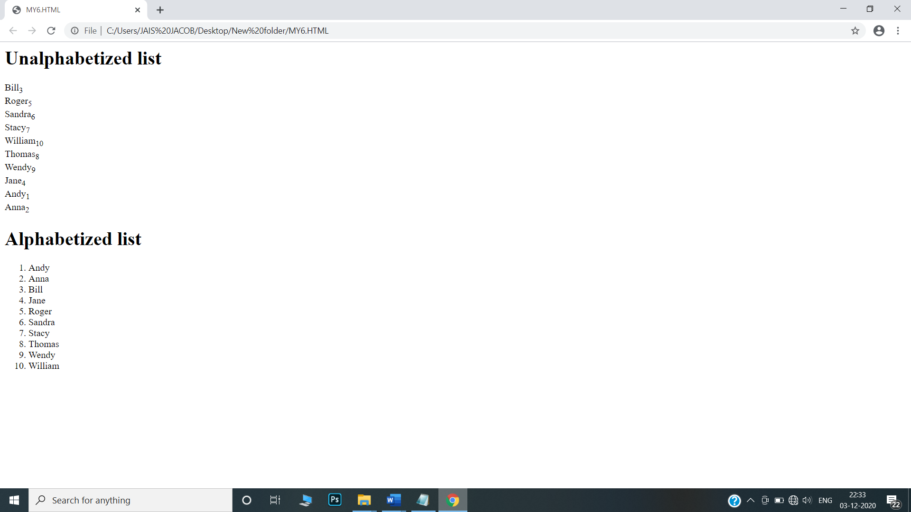

7. Print the squares of the numbers 1 - 20. Each number should be on a separate line, next to it the number 2 superscripted, an equal sign and the result

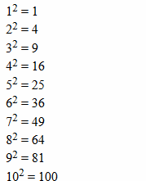

<html>

<head>

<title> squares</title> </head>

<body>

1<sup> 2 </sup> = 1<br>

2<sup> 2 </sup> = 4<br>

3<sup> 2 </sup> = 9<br>

4<sup> 2 </sup> = 16<br>

5<sup> 2 </sup> = 25<br>

6<sup> 2 </sup> = 36<br>

7<sup> 2 </sup> = 49<br>

8<sup> 2 </sup> = 64<br>

9<sup> 2 </sup> = 81<br>

10<sup> 2 </sup> = 100<br>

11<sup> 2 </sup> = 121<br>

12<sup> 2 </sup> = 144<br>

13<sup> 2 </sup> = 169<br>

14<sup> 2 </sup> = 196<br>

15<sup> 2 </sup> = 225<br>

16<sup> 2 </sup> = 256<br>

17<sup> 2 </sup> = 289<br>

18<sup> 2 </sup> = 324<br>

19<sup> 2 </sup> = 361<br>

20<sup> 2 </sup> = 400<br>

</body>

</html>

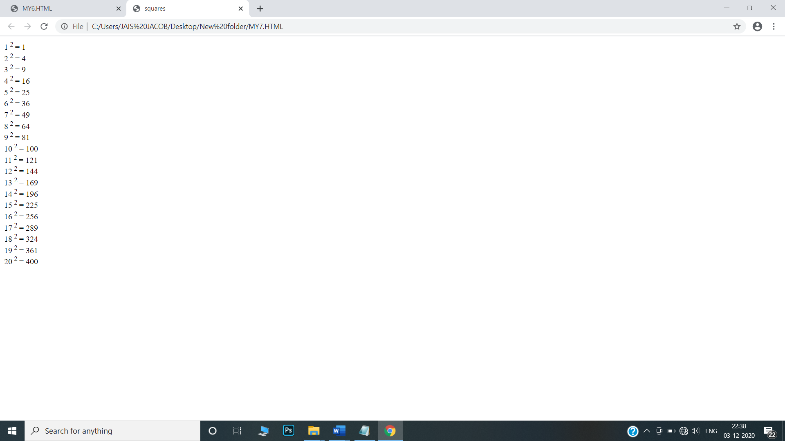

8. Print a definition list with 5 items.

<html>

<head>

<title> definition list </title> </head>

<body>

<dl>

<dt>NAT</dt>

<dd>Network Address Translation</dd>

<dt>SSH</dt>

<dd>Secure Shell</dd>

<dt>DHCP</dt>

<dd>Dynamic Host Configuration Protocol</dd>

<dt>BGP</dt>

<dd>Border Gateway Protocol</dd>

<dt>TCP</dt>

<dd>Transmission Control protocol</dd>

</dl>

</body>

</html>

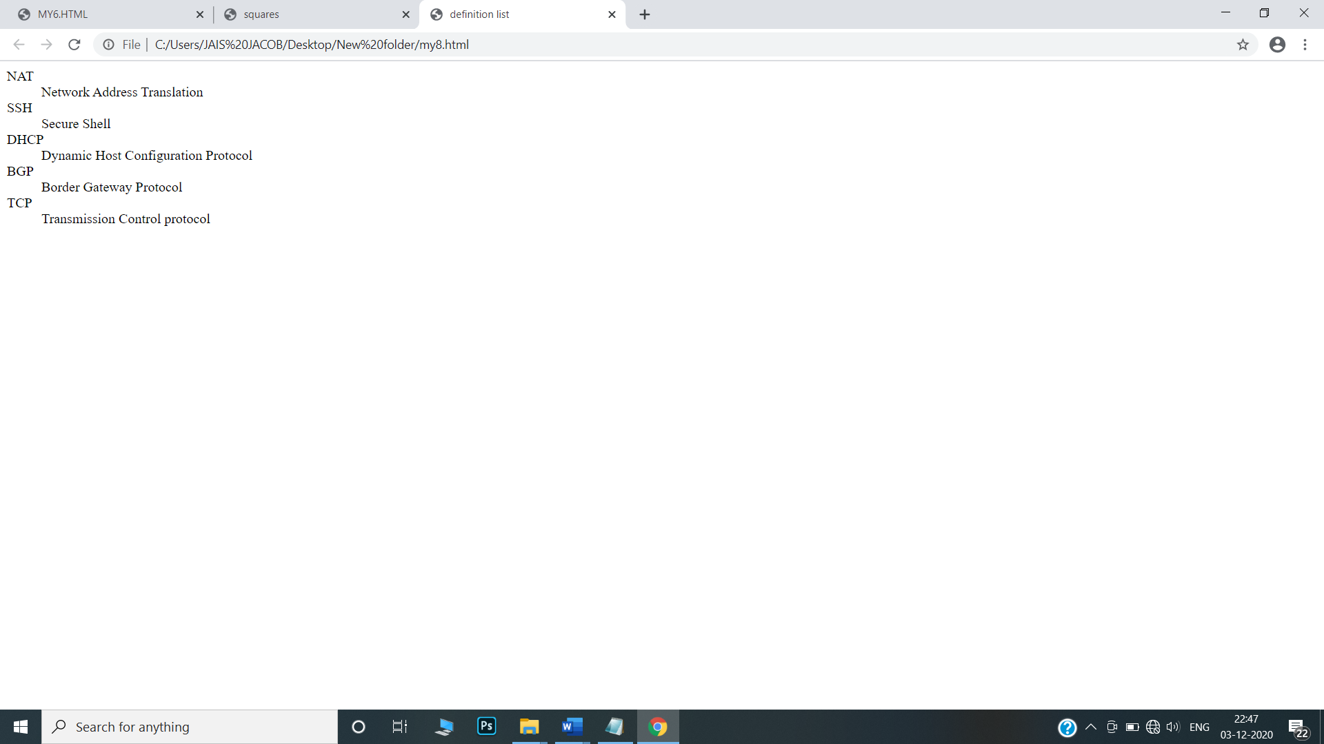

9.Display an image that has a border of size 2, a width of 200, and a height of 200.

<html>

<head>

</head>

<body>

<img src="C:\Users\JAIS JACOB\Desktop.jpg" alt="phone" border="2" width="200" height="200"/>

</body>

</html>

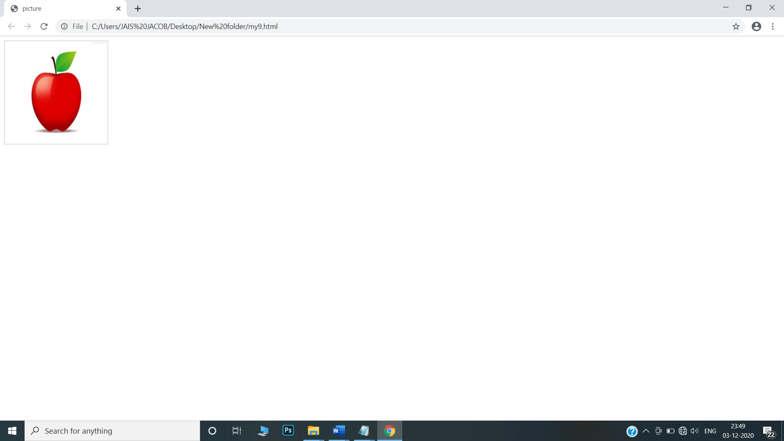

10.Print ten acronyms and abbreviations of your choosing, each separated by two lines. Specify the data that the abbreviations and acronyms represent

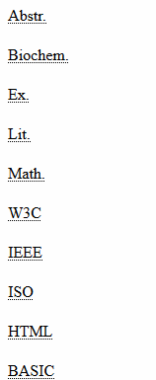

<html>

<head>

<title>Abbreviation</title></head>

<body>

<abbr title="abbstract"> Abstr.</abbr><br><br>

<abbr title="Biochemistry"> Biochem.</abbr> <br><br>

<abbr title="Example"> Ex.</abbr> <br><br>

<abbr title="Literature"> Lit.</abbr> <br><br>

<abbr title="Mathematics"> Math.</abbr> <br><br>

<abbr title="World Wide Web Consortium"> W3C.</abbr> <br><br>

<abbr title="Institute of Electrical and Electronic Engineers"> IEEE.</abbr><br><br>

<abbr title="International standards Organisation"> ISO.</abbr> <br><br>

<abbr title="Hyper Text Markup Language"> HTML.</abbr> <br><br>

<abbr title="Beginners All Purpose Smbolic Instruction Code"> BASIC.</abbr> <br><br>

</body>

</html>

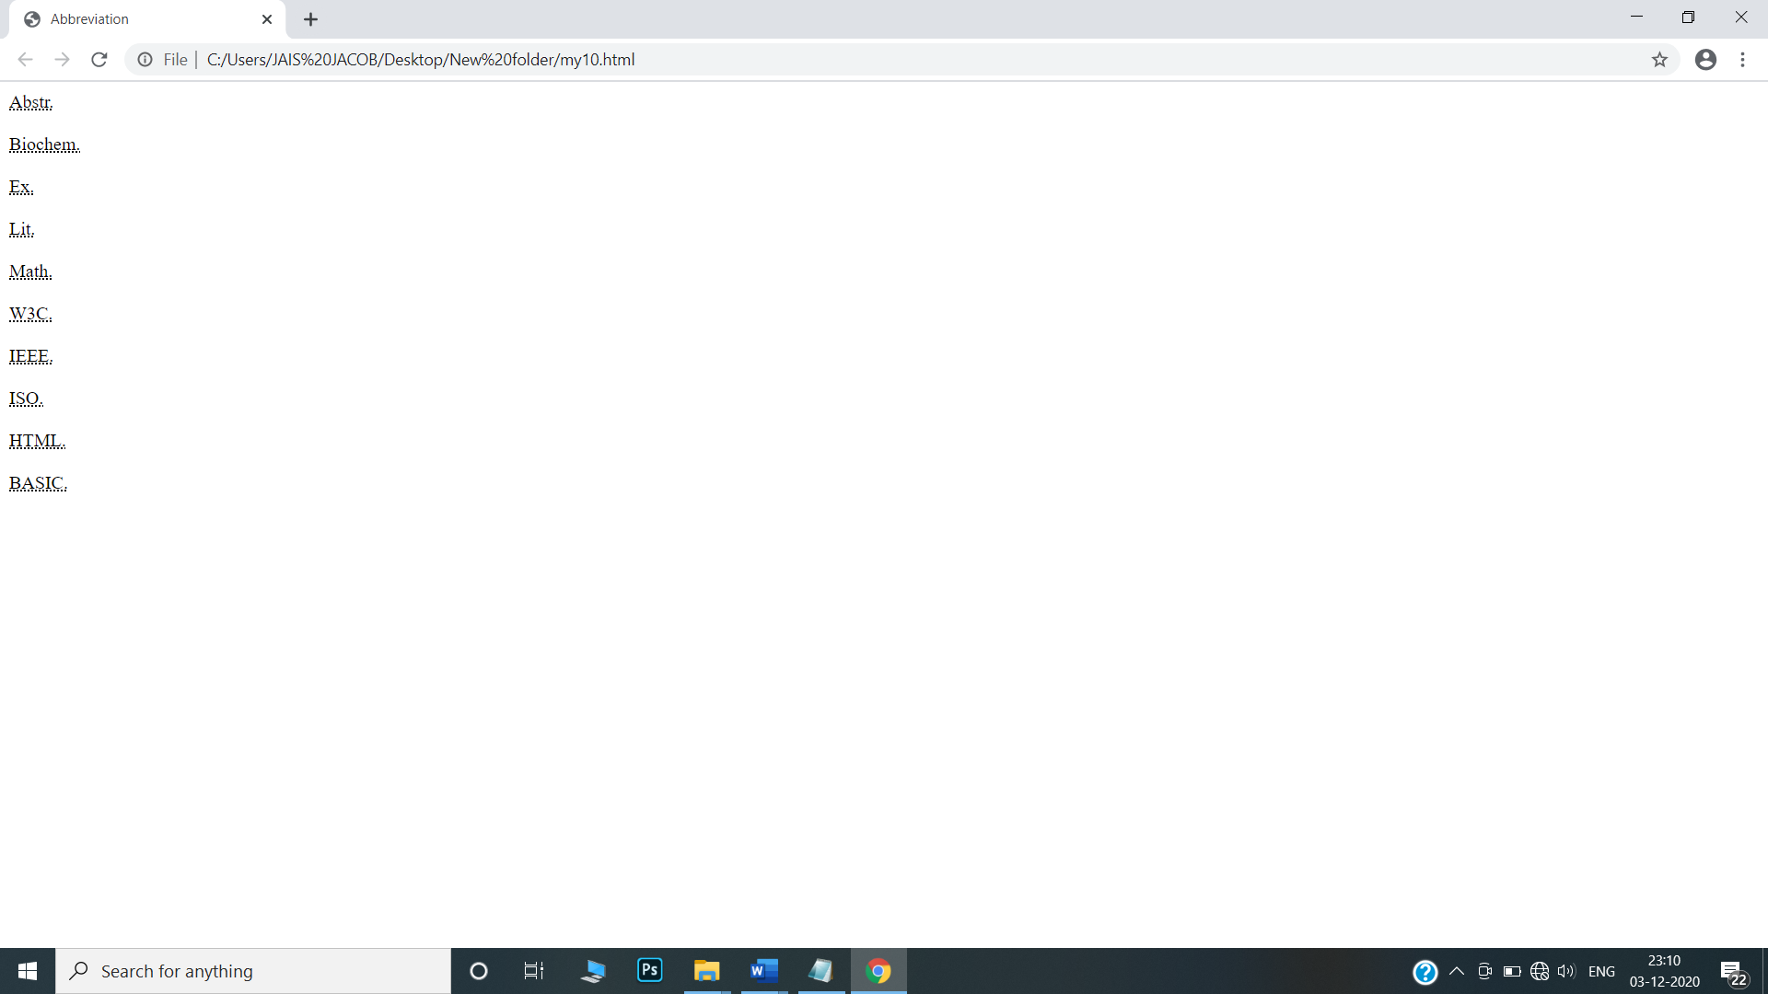

11. Print two addresses in the same format used on the front of envelopes (senders address in top left corner, receivers address in the center

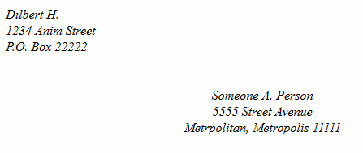

<html>

<head>

</head>

<body>

<address>

<br>

Dilbert H.

<br>

1234 Anim Street

<br>

P.O. Box 22222

</address>

<br><br>

<center>

<address>

Someone A. Persion

<br>

5555 Street Avenue

<br>

Metrpolitan, Metropolis 11111

</address>

</center>

</body>

</html>

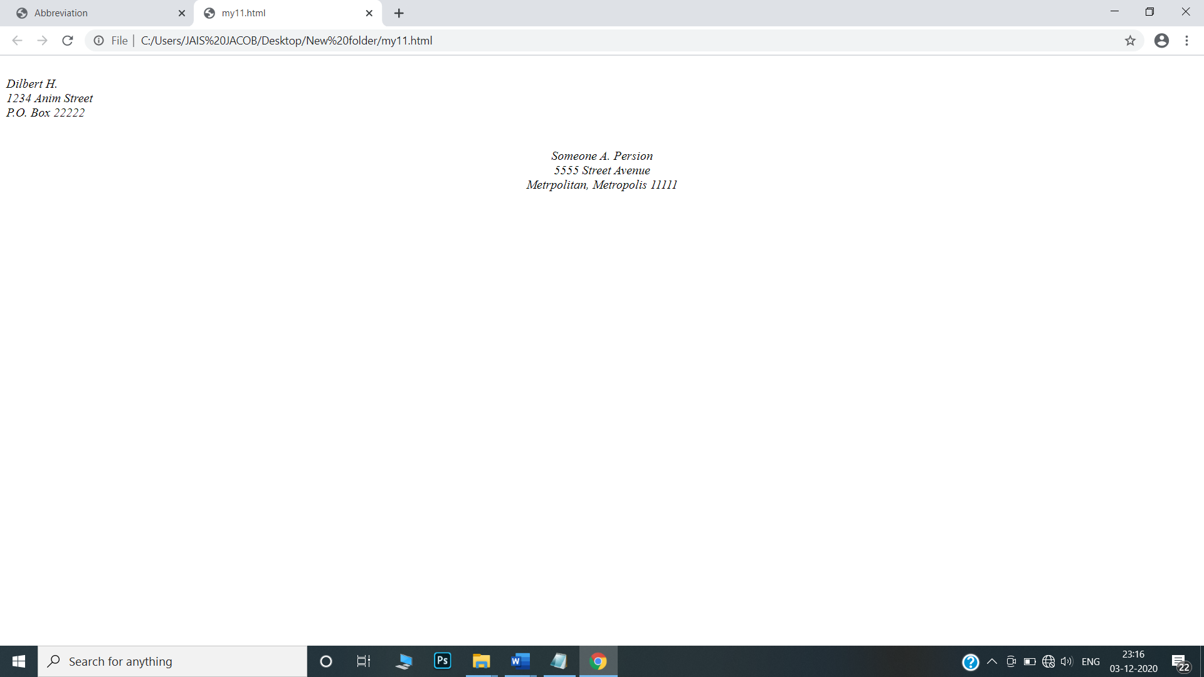

12.Create an HTML page with the following contents:

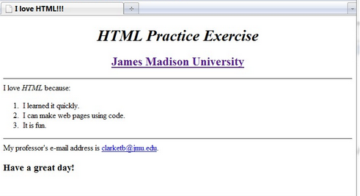

<html>

<head>

<title> I love HTML!!! </title></head>

<body>

<h1 align="center"><i> HTML Parctice Exercise </i> </h1>

<h2 align="center" style="color:purple;"><u> <b>James Madison University</b> </u> </h2>

<hr>

<p> I love <i> HTML </i> beacuse: </p>

<ol type="1">

<li> I learned it quickly. </li>

<li> I can make web pages using code. </li>

<li> It is fun </li>

</ol>

<hr>

<p> My professor's e-mail address is <a href="#">clarkrtb@jmu.edu </a> </p>

<h2>Have a great day!</h2>

</body>

</html>

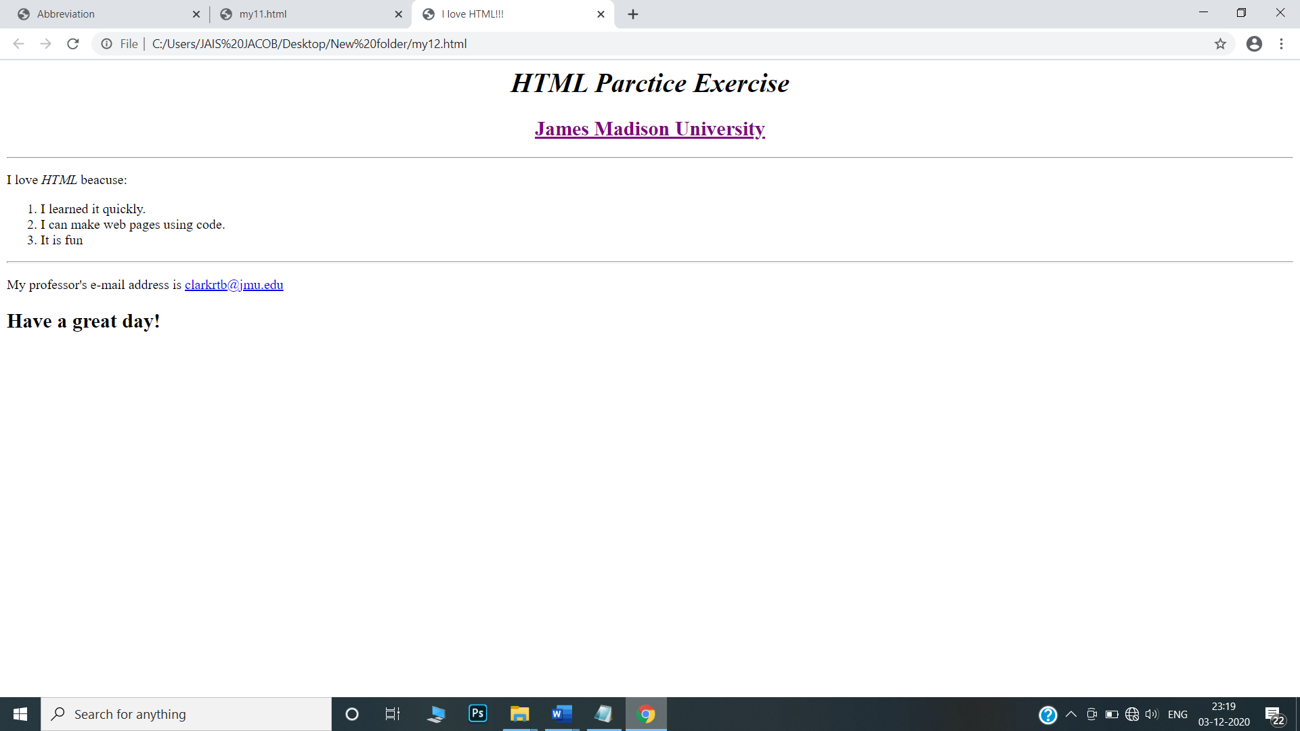

13.Create the following table

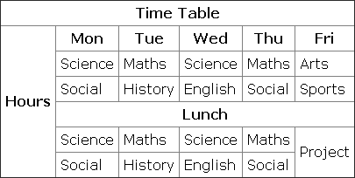

<html>

<head>

<title> Time Table </title>

</head>

<body>

<table border="1" cellspacing="0">

<tr>

<th colspan="6"> Time Table</th>

</tr>

<tr>

<th rowspan="6">Hours</th>

<th> Mon </th>

<th> Tue </th>

<th> Wed </th>

<th> Thu </th>

<th> Fri </th>

</tr>

<tr>

<td> science </td>

<td> maths </td>

<td> science </td>

<td> maths </td>

<td> arts </td>

</tr>

<tr>

<td> scoial </td>

<td> history </td>

<td> engilsh </td>

<td> social </td>

<td> sports </td>

</tr>

<tr>

<th colspan="5"> Lunch</th>

</tr>

<tr>

<td> science </td>

<td> maths </td>

<td> science </td>

<td> maths </td>

<td rowspan="2" > project </td>

</tr>

<tr>

<td> scoial </td>

<td> history </td>

<td> engilsh </td>

<td> social </td>

</tr>

</table>

</body>

</html>

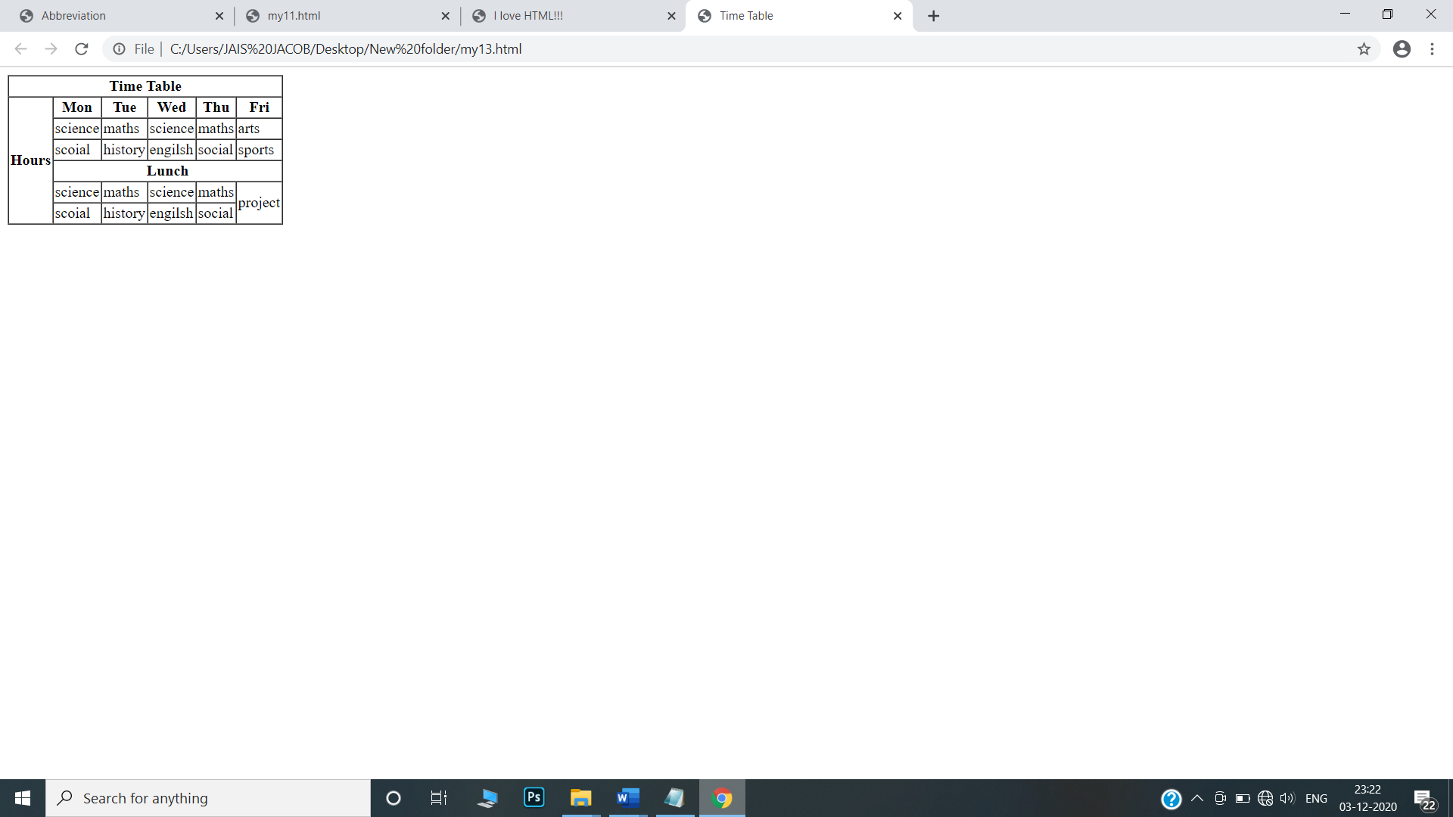

14.Create a HTML Page which looks like the one given below

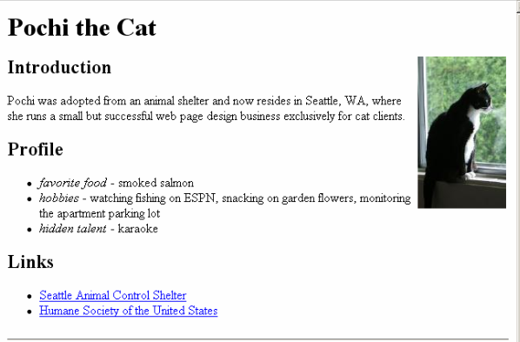

<html>

<head>

</head>

<body>

<h1><b>Pochi the Cat</b></h1>

<img src="D:\images.jpeg" alt="Pochi" height="250" width="200" align="right" hspace="390"/>

<h2><b>Introduction</b></h2>

<p>Pochi was adopted from an animal shelter and now resides in Seattle, WA,where she runs a small but successful web page design business exclusively for cat clients.</p>

<h2><b>Profile</b></h2>

<ul>

<li><i>favorite food-</i>smoked salmon</li>

<li><i>hobbies-</i>watching fishing on ESPN , snacking on garden flowers, monitoring the apartment parking lot.</li>

<li><i>hidden talent-</i>karaoke</li>

</ul>

<h2><b>Links</b></h2>

<li><a href="Seattle Animal Control Shelter">Seattle Animal Control Shelter</a></li>

<li><a href="Humane Society of the United States">Humane Society of the United States</a></li>

</body>

</html>

